Cybersecurity Internship Report: Task 1
Student: Febin Maxon

Objective:
Discover open ports on local and remote devices to evaluate network exposure and identify potential security risks.

Tools I have Used:
- Nmap - Network discovery and scanning tool.
- Wireshark - Network packet analysis tool.
- Gobuster - Web directory brute-forcing tool.

Network Reconnaissance & Findings
performed port scans using Nmap on both my local virtual environment and a web called testphp.vulnweb.com where testing is allowed.

- Local Network Scan
As shown in my terminal screenshot, scanning the subnet revealed several active hosts:
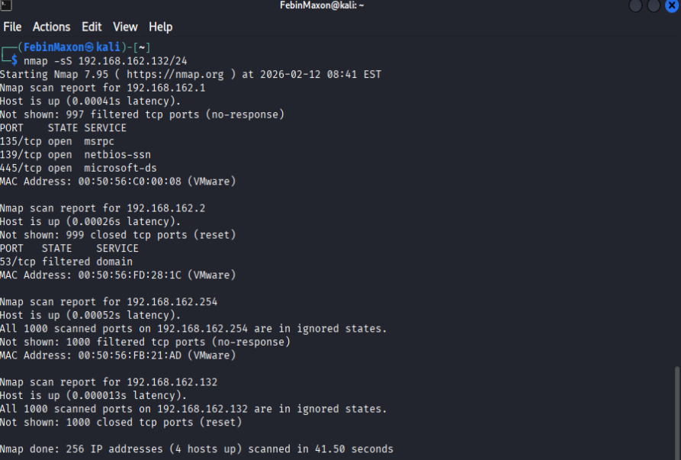
- Target $192.168.162.1$ (VMware Host):

- Port 139/tcp (netbios-ssn): NetBIOS Session Service.
(Risk Level: Medium, Enables NetBIOS enumeration (usernames, shares, system info), Used in credential harvesting attacks in poorly secured networks.)

- Port 445/tcp (microsoft-ds): SMB (Server Message Block) used for file/printer sharing.
(Risk Level: High, Exploitable vulnerabilities (e.g., EternalBlue / WannaCry), Can allow remote execution if misconfigured)

- Port 53/tcp (domain): Filtered; likely a DNS service.
(Risk Level: Low–Medium or lower if properly firewalled, If misconfigured, can allow DNS zone transfer attacks, Filtered status suggests firewall protection, reducing risk)

- Improvised Scan on testphp.vulnweb.com
I extended the task by scanning testphp.vulnweb.com
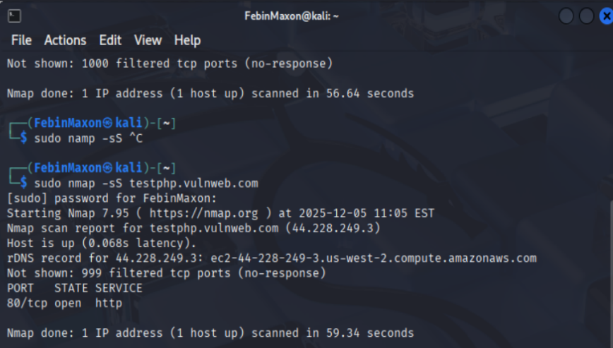
- Port 80/tcp (http): The default port for unencrypted web traffic.
(Risk Level: Medium–High)
  - depends on whether HTTPS is enforced and web app security.
  - Data transmitted is unencrypted, making it vulnerable to packet sniffing (credentials, session cookies, form data).
  - Susceptible to Man-in-the-Middle (MITM) attacks.
  - Vulnerable to common web attacks if the application is insecure (e.g., SQL Injection, XSS, file inclusion).

- Directory Enumeration Findings (Gobuster)

I Used directory brute-forcing, paths were identified:
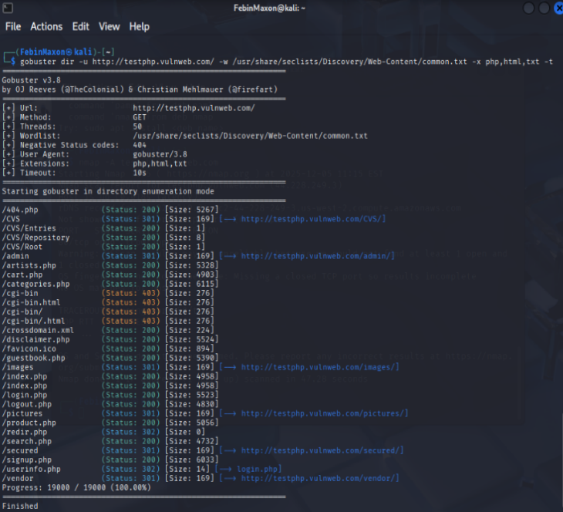

/admin
Risks:
- Likely administrative panel.
- High risk of brute-force attacks if authentication is weak.
- May expose sensitive configuration or management functions.
- If improperly secured, could allow privilege escalation.
Risk Level: High

/login.php
Risks:
- Target for credential brute-forcing and password spraying.
- Vulnerable to SQL injection if input validation is weak.
- May expose user enumeration through different error messages.
- Risk of session hijacking if not protected by HTTPS.
Risk Level: Medium–High
/secured/
Risks:
- Suggests restricted or sensitive content.
- If access controls are misconfigured, may allow unauthorized data access.
- Possible exposure of confidential files or backups.
- May be vulnerable to directory listing if indexing is enabled.
Risk Level: Medium–High (depends on access control implementation)

- Wireshark Traffic Analysis – HTTP Credential Exposure

- HTTP POST request sent to /userinfo.php
- Content-Type: application/x-www-form-urlencoded
- Credentials visible in plaintext:
- uname = FebinMaxon
- pass = 1979
- Connection over HTTP (not HTTPS)
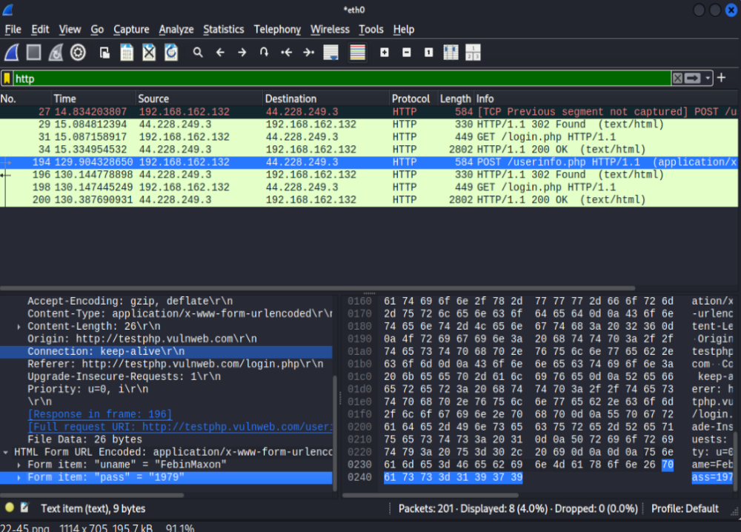

Security Risks

1. Plaintext Credential Exposure (Critical Risk)
- Username and password are transmitted unencrypted.
- Anyone on the same network can capture credentials using packet sniffing tools (e.g., Wireshark).
- Enables credential theft and account compromise.
Risk Level: Critical

2. Lack of HTTPS Encryption
- No TLS/SSL protection.
- Vulnerable to:
  - Man-in-the-Middle (MITM) attacks
  - Session hijacking
  - Traffic manipulation
- Attackers can modify or replay requests.
Risk Level: High

3. Session & Data Integrity Risk
- Login responses (302 redirect → 200 OK) also unencrypted.
- Session cookies (if present) could be stolen.
- Enables unauthorized access without password cracking.
Risk Level: High

Conclusion
This task provided a hands-on introduction to the foundational phase of any security assessment: Network Reconnaissance. By utilizing Nmap, I successfully identified active hosts and open services within both a local virtual environment and a remote target.

